SELECT reg.region_name, COUNT(*)

FROM employees emp

FULL JOIN departments dep ON emp.department_id = dep.department_id

FULL JOIN locations loc ON dep.location_id = loc.location_id

FULL JOIN countries con ON loc.country_id = con.country_id

FULL JOIN regions reg ON con.region_id = reg.region_id

GROUP BY reg.region_name

CREATE TABLE tab_reg

("REG_NAME" VARCHAR2(25 BYTE),

"NUMBER OF PEOPLE" INT)

INSERT INTO tab_reg

SELECT reg.region_name, COUNT(*)

FROM employees emp

LEFT JOIN departments dep ON emp.department_id = dep.department_id

LEFT JOIN locations loc ON dep.location_id = loc.location_id

LEFT JOIN countries con ON loc.country_id = con.country_id

LEFT JOIN regions reg ON con.region_id = reg.region_id

GROUP BY reg.region_name;

COMMIT;

COMMENT ON COLUMN tab_reg.REG_NAME IS 'НАИМЕНОВАНИЕ РЕГИОНА';

COMMENT ON COLUMN tab_reg.NUMBER_OF_PEOPLE IS 'КОЛИЧЕСТВО ПРОЖИВАЮЩИХ В РЕГИОНЕ';

COMMIT;

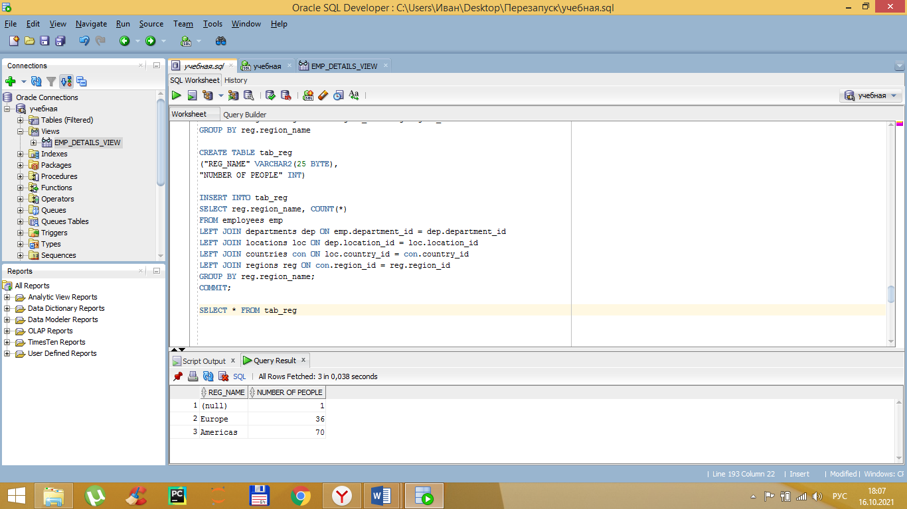

2.

